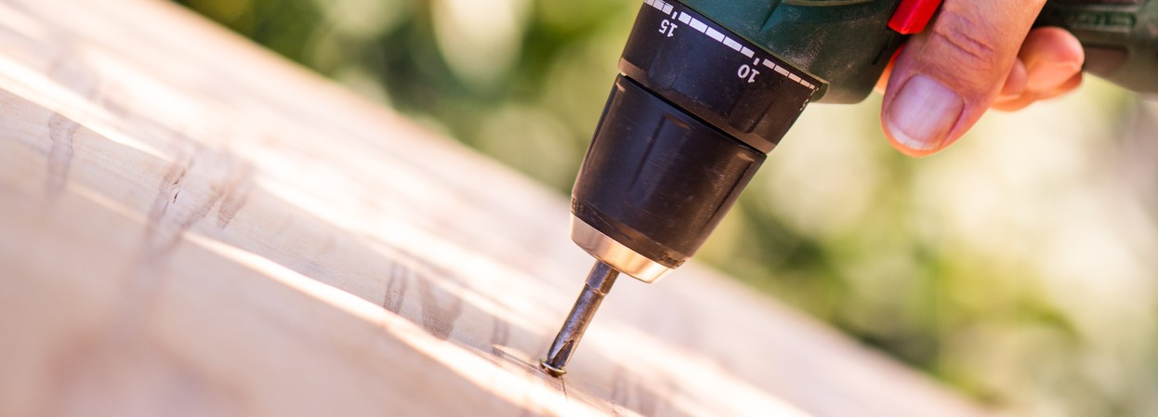

Guidelines for installing window canopy kit: Window Canopy Kit & Assembly
Installing a window canopy kit can be a great DIY project to enhance the aesthetic of your home and provide some shade and protection for your windows. Here are step-by-step assembly guidelines for installing the window canopy kit.
Before You Start
- Ensure you have all the necessary equipment and materials.
- Prime all timber components with an oil-based paint as per the Osmose guarantee requirement.
Kit contents
Window canopy kits are made from LOSP pressure treated pine.
- 2 x pre-assembled canopy end frames (1 left and 1 right)
- 3 x battens for fixing iron
- Precut ripple iron for straight roofed models
- Pre-cut custom orb for arched roof
- 1 x shaped fascia board
- 2 x sets timber end caps
- Assembly screws:
- 4 large coach screws and washers for mounting wall brackets
- 12 color matched roofing screws for every 2 metres of colourbond iron
- 6 x 50mm screws for fixing battens
- 4 x 30mm screws for fixing end caps
- 4 x 25mm screws for fixing fascia board
Skill level Experienced DIY

Equipment required
- Drill
- Phillips head screw driver
- Saw to cut battens to length
- Tape measure
- Pencil
- Square
Step 1: Mark the Studs and Height
- Use a tape measure or ruler to find and mark the location of the wall studs on either side of the window. These should be approximately 50mm to 150mm from the edges of the window.
- Mark the height where the canopy will sit above the window. This will help you position the canopy correctly.
Step 2: Install Left Canopy Frame
- Use two coach screws to attach the left canopy frame to the wall. Ensure you align it with the marked studs and at the correct height. Use the height marking as a reference to make sure it's level and vertically straight.
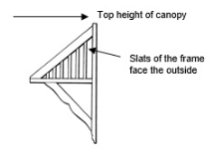
Step 3: Install Right Canopy Frame
- Repeat the same process as in Step 2 to attach the right canopy frame to the other side of the window. Make sure it is also aligned with the marked studs and at the same height as the left frame.

Step 4: Cut and Install Battens
- Cut three battens to the required length, which should be the distance from the outer edge of the left canopy frame to the outer edge of the right canopy frame.
- Using 50mm screws, attach the battens to the top of the canopy frames in the following positions:
  - 1st batten across the top of the two brackets.
  - 2nd batten across the middle.
  - 3rd batten across the bottom.
Step 5: Install Fascia Board
- Cut the fascia board to the correct length, which should be from the outer edge of the face of the left wall bracket to the outer edge of the face of the right wall bracket.
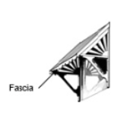
- Attach the fascia board to the front of the wall brackets using 25mm screws.

Step 6: Install Roofing
- Place the pre-cut ripple iron or custom orb (depending on your canopy type) on top of the battens with the gullies running in the desired direction.
- Secure the roofing material to the battens using the color-matched roofing screws.
Step 7: Install End Caps
- Position the left end cap flashing on top of the roofing material with the smaller edge sitting on the roofing material. The end cap should be flush against the wall.
- Secure the left end cap in place using 30mm screws.
- Repeat this process with the right end cap flashing on the other side.
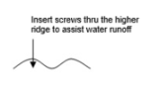

Once you have completed these steps, your window canopy kit should be securely installed and provide the intended shade and protection to your windows. Make sure everything is properly tightened and aligned for a finished and functional installation.

