
How to: Measure up for Interior Fretwork
Measuring up for assembled interior fretwork is a straightforward process, whether you choose to do it yourself or have a professional like a builder, carpenter, or handyman take the measurements. Here's how:
1. Start at the Highest Point
Measure the distance from one wall to another at the highest point in your space. Always prioritise safety, especially when working at a height.
2. Take a Second Measurement
Lower your measurement point by 300 to 600mm (whichever is most suitable for your fretwork). Measure the width from wall to wall once more.
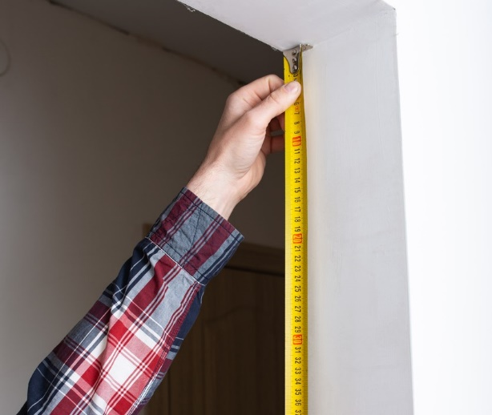

It's important to note that in older homes, walls may not be perfectly square. As a result, the fretwork will be made to accommodate the widest measurement, and minor on-site adjustments to the sides can be made during installation. If necessary, the sides of the fretwork frame can be trimmed using a plane.
Accuracy is key since the fretwork will be tailored to these dimensions.

Considerations when Determining the Length of the fretwork
When determining the length (drop), keep the following considerations in mind:
1. Physical limitations
Be mindful of any physical obstacles, such as picture rails, door frames, or other structural features, that may affect the drop length.

2. Proportion
Keeping fretwork proportion in mind is important. Some designs will allow you to specify the length whilst others will not. For example, the HFR1 is very versatile and remains proportionate with both short and long drops. However, designs with intricate, detailed patterns are more restricted. For detailed pieces such as the HFR10 the length will be determined by the width. If unsure contact us for advice.

