Measure Up Windows for Timber Curtain Rods

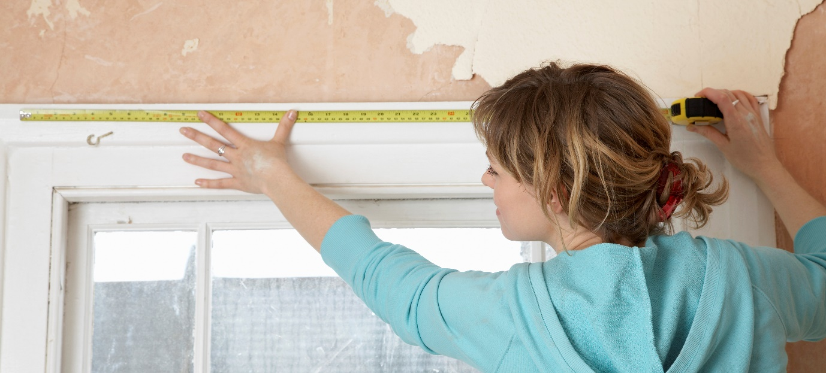
A Guide to Measuring Your Windows for Wooden Curtain Rods

Step 1: Gather your tools.
Before you begin, gather the following tools:
- Measuring tape
- Pencil
- Notepad or paper to jot down the measurements.

Step 2: Decide on the Size (diameter)of the Curtain Rod
There are several standard options available, ranging from 29mm diameter to 50mm diameter. Beyond this, custom sized dowels may also be possible. When choosing the diameter consider the following:
- Weight of your curtains
- Style and visual impact
- Curtain hardware
Step 3: Measure the width
To measure the width of your window, start by measuring the inside width of the window frame. Place your measuring tape at the top of the frame and extend it to the opposite side. Note down this measurement. If you prefer your curtains to cover a larger area, you can extend the measurement beyond the frame on both sides.
Step 4: Determine the rod length
Next, consider how far beyond the window frame you want your curtain rod to extend on each side. Typically, adding around 4 to 6 inches to the window width on each side is recommended for a full and elegant look. Note down this measurement as well. Remember also to include the length of the finials at each end of the rod.
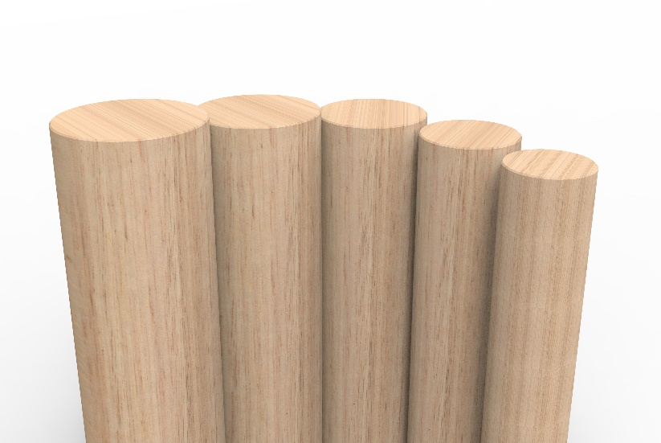

Step 5: Measure the height
To measure the height of your window, start from the top of the window frame and extend the measuring tape down to the desired length of your curtains. Consider whether you want your curtains to fall just below the window sill, at floor level, or create a pooling effect. Note down the measurement.
Step 6: Consider Bracket placement
Now that you have the width and height measurements, you need to determine the appropriate placement of the brackets. For standard curtain rods, place the brackets approximately 100 to 150mm from the sides of the window frame, ensuring they are level.
Step 7: Double-check your measurements
Before finalising your curtain rod and bracket purchase, double-check all your measurements. Ensure they are accurate and take into account any special considerations, such as obstructions or trim that may affect the installation.
Taking the time to measure your windows properly for curtain rods and brackets is a crucial step in achieving a polished and well-dressed window treatment. By following these simple steps, you can confidently select the right curtain hardware and create a stunning display that complements your space. Remember, accuracy is key, so measure twice and install once for a perfect fit and a beautifully adorned window.

