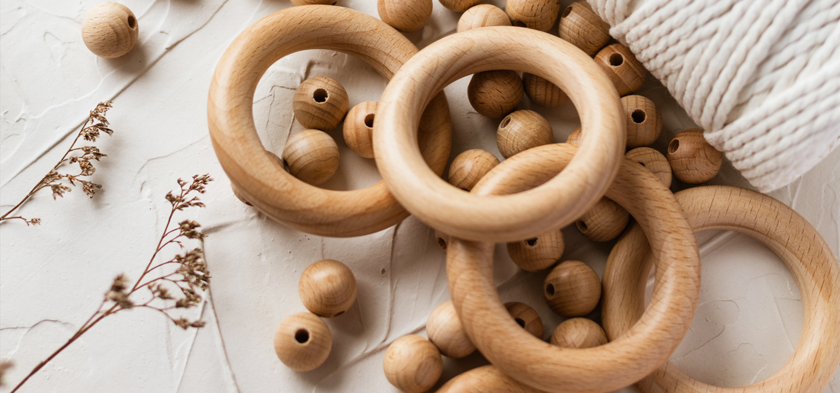

Calculating the Quantity of Curtain Rings for Your Rods
A Practical Guide

What you will find in this Guide (3min read)
Introduction
Key Formula
Typical Spacings for Hanging Styles
Casual Look
Softly Tailored Look
Richly Gathered Look
Notes and considerations
Quick Reference Table

Introduction
Curtain rings aid in hanging and sliding curtains along a rod. The number of rings depends on rod length, desired fullness, and curtain style. This guide uses a 2100 mm rod to illustrate how to estimate ring count.

Key Formula

Rings needed = rod span divided by ring spacing
Wider spacing means fewer rings; tighter spacing means more rings.

Typical Spacings for Hanging Styles
Casual Look
Curtains hung for a casual look present an uncomplicated, relaxed feel. The fabric drapes softly with gentle, even folds and a light, unobtrusive header—often a simple rod pocket, tab top, or a basic pleat that doesn’t pin the fabric into tight, rigid shapes. Rings or hooks are spaced relatively wide (around 100 mm apart in many setups), delivering a laid-back sweep with visible but unobtrusive movement. The overall effect is airy, easy going, and versatile, suitable for everyday living spaces where comfort and practicality trump formal polish. Key elements:
- Moderate to light fabric weight for easy handling
- Wider ring spacing for a relaxed drape
- Minimal or no elaborate pleating
- Simple hardware that blends with the room’s decor
- Clean, uncomplicated hems and edges for a casual vibe

Ring Calculation
Generally, rings for a casual look are spaced approximately 100mm apart. Based upon this estimate, the number of rings required is calculated as:
Rod length: 2100mm
Spacing distance: 100mm
Rod length divided by spacing
2100/ 100
= 21 rings

Softly Tailored Look
A curtain hung for a softly tailored look strikes a balanced, polished tone. The fabric falls in gentle, well-defined folds that hold their shape without appearing stiff. Header details are usually neater—think soft pinch-pleats or a tailored box-pleat, or a clean rod pocket with light draping. Ring or hook spacing is intermediate (around 60–70 mm apart), giving a steady, even sweep that enhances the drape without looking flimsy or overly formal. The room feels put-together yet approachable, with enough fullness to frame the window nicely while preserving easy light control.
Key elements:
- Medium-weight fabric with a soft, structured drape
- Ring spacing about 60–70 mm for balanced fullness
- Neatly finished hems and minimal decorative hardware
- Versatile look that suits living spaces, dining areas, and bedrooms without feeling overly dressy

Ring Calculation
Rings for a softly tailored look are spaced approximately 60-70mm apart, depending on your preference.
Rod length: 2100mm
Spacing distance: 70mm
Rod length divided by spacing
2100/ 70
= 30 rings

Richly Gathered Look
A curtain hung for a full look wraps the window in a lush, enveloping drape. The fabric appears rich and voluminous, with many tight folds and a strong sense of body and texture. Header details are often heavily tailored—think pinch-pleats or box-pleats that create structured, prominent fullness. Ring or hook spacing is tight (around 40–50 mm apart), producing a dense, rippled sweep that looks substantial even when the curtain is drawn. The overall effect is opulent and cinematic, lending a sense of grandeur and coziness to the room.
Key elements:
- Heavier or multi-layered fabric to enhance body and opacity
- Dense fullness with clearly defined folds
- Pleated or heavily tailored header (pinch-pleat, box-pleat) for strong structure
- Tight ring spacing (roughly 40–50 mm) for a compact, plush appearance
- Substantial hems and richer texture to emphasize weight and presence
- Suitable for formal spaces or rooms where a dramatic, luxurious atmosphere is desired

Ring Calculation
Rings for a Richly Gathered look are spaced approximately 40-50mm apart, depending on your preference.
Rod length: 2100mm
Spacing distance: 50mm
Rod length divided by spacing
2100/ 50
= 42 rings

Notes and considerations
- Always round up to a whole ring.
- If using pleated curtains, add rings per pleat as required by the header design.
- Check manufacturer recommendations for your curtain type.
- For very light fabrics, you may use fewer rings; for heavier fabrics, more rings help distribute weight.

Quick Reference Table

Guide Quantity of Curtain Rings
 | Hung Style | Casual | Softly Tailored | Richly Gathered
 | Ring spacing (mm) | 100 | 60 - 70 | 40 - 50
Rod Length | 1200 | 12 | 17 - 20 | 24-30
 | 1500 | 15 | 21 - 25 | 30-37
 | 1800 | 18 | 26 - 30 | 36-45
 | 2100 | 21 | 30 - 35 | 42-52
 | 2400 | 24 | 24 - 40 | 48-60
 | 3000 | 30 | 42 - 50 | 60-75

